PANCHMURA MAHAVIDYALAYA
Department of Education

Date:-26/02/2024

Notice

All the students of Education Department ( SEM-III,SEM-V) are here by informed that their Education practical examination will be held according to the following time table.

Name Of The Department | Semester | Student Type | Course Code | Course Title | Date Of Exam | Time Of Exam | Venue
EDUCATION | SEM-III | HONS. | AH/EDN/305/SEC- 1A | COMPUTER  APPLICATION IN EDUCATION | 09/03/  2024 | 10.00am to  12.00 am | Home Centre
 | SEM – V | PROG. | AP/EDN/504/SEC-3 | SCHOOL ACTIVITY  SURVEY | 12/03/2024 | 10.00am to  12.00 am | Home Centre

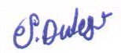
Signature of Principal

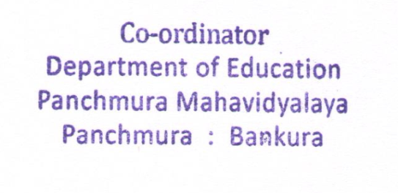
COD
Department of Education

